PostgreSQL server Advanced 2

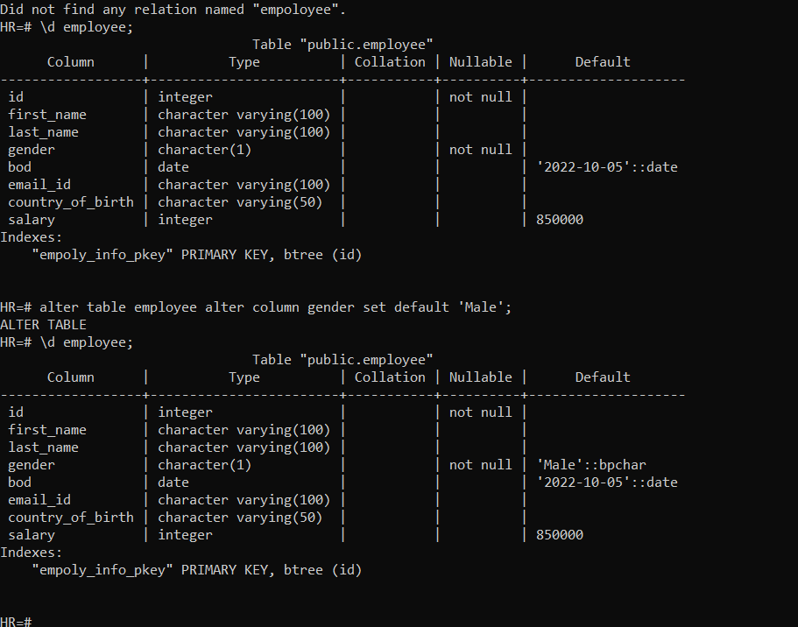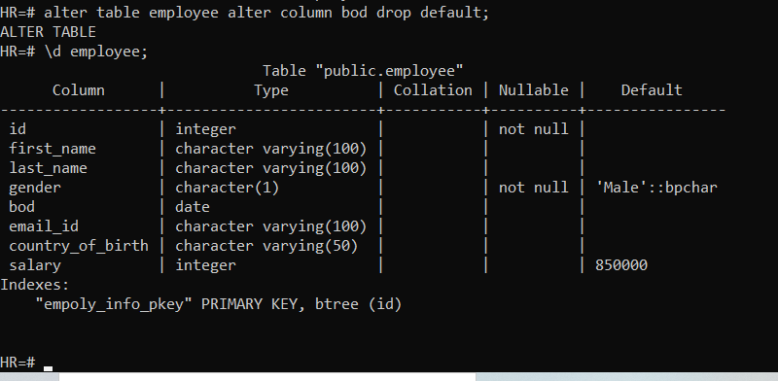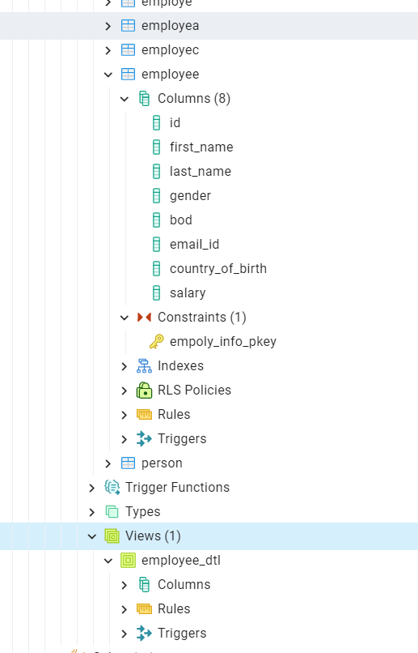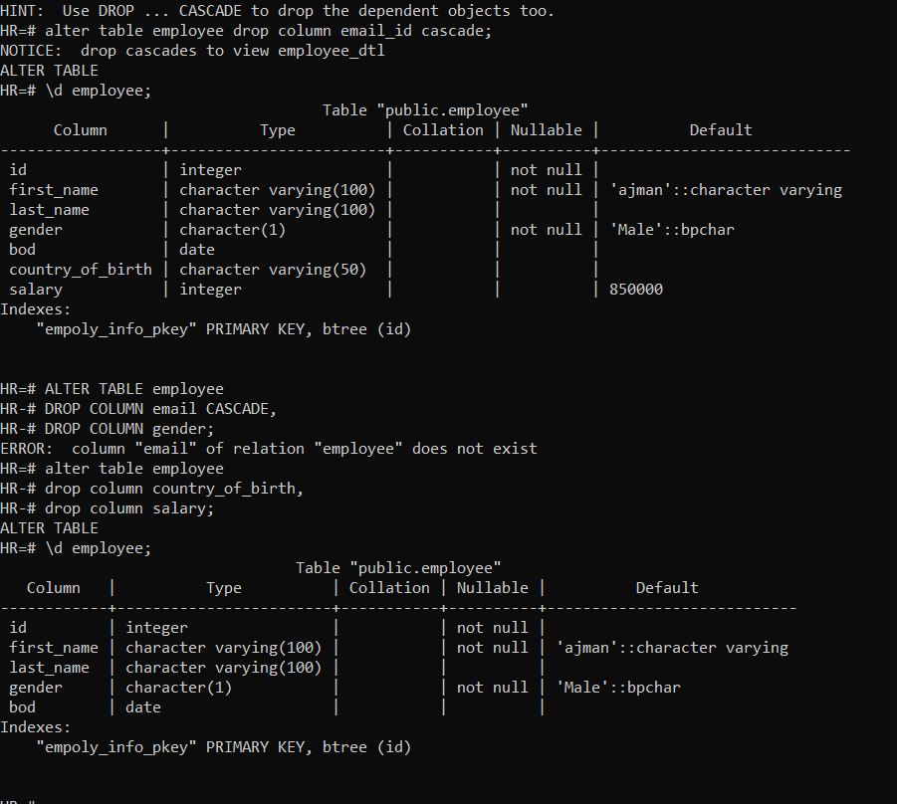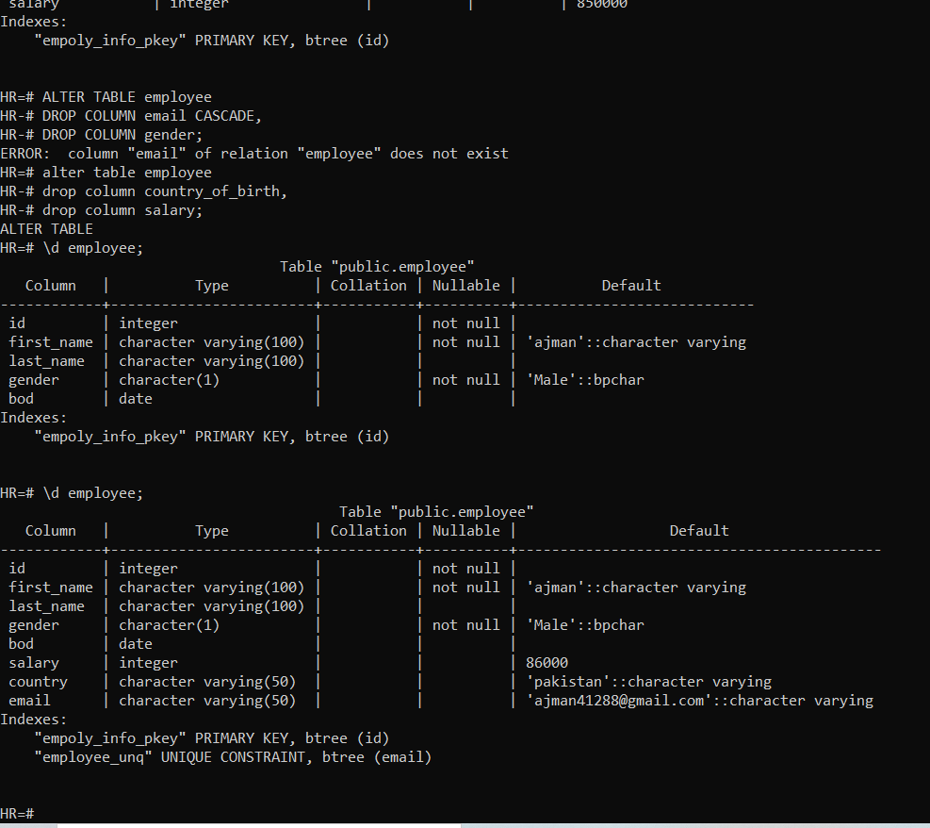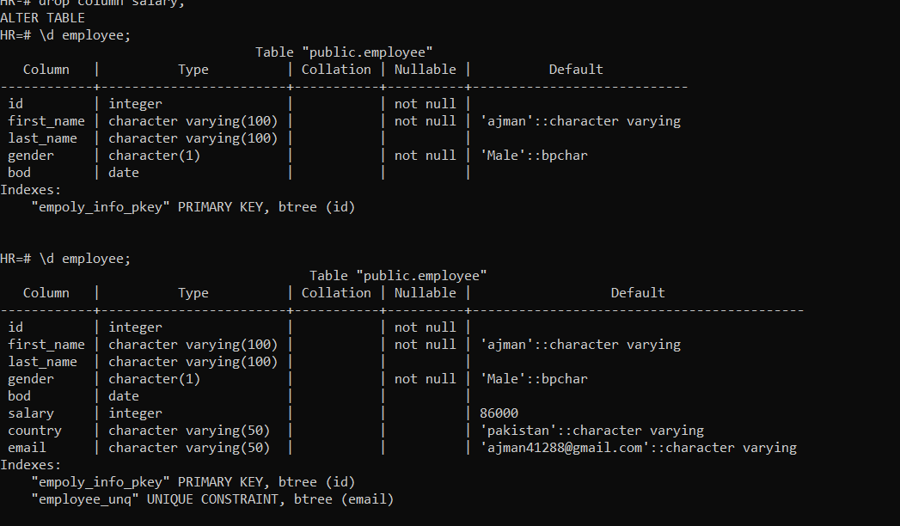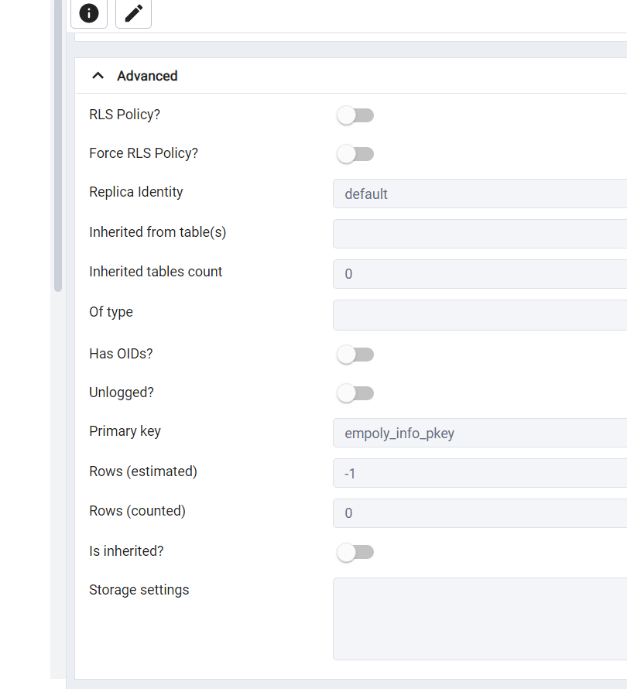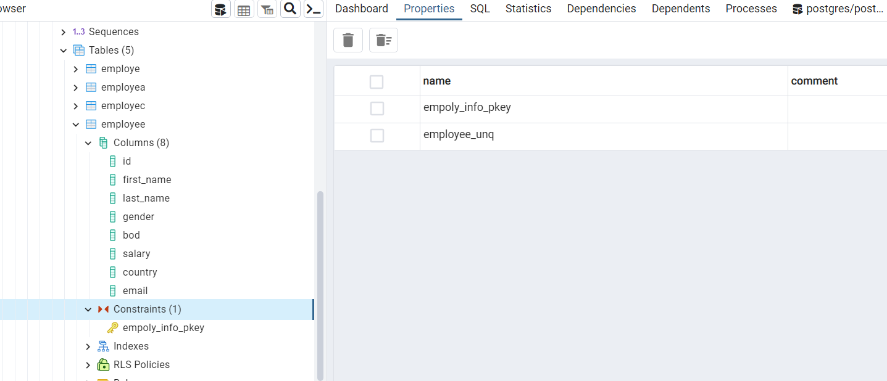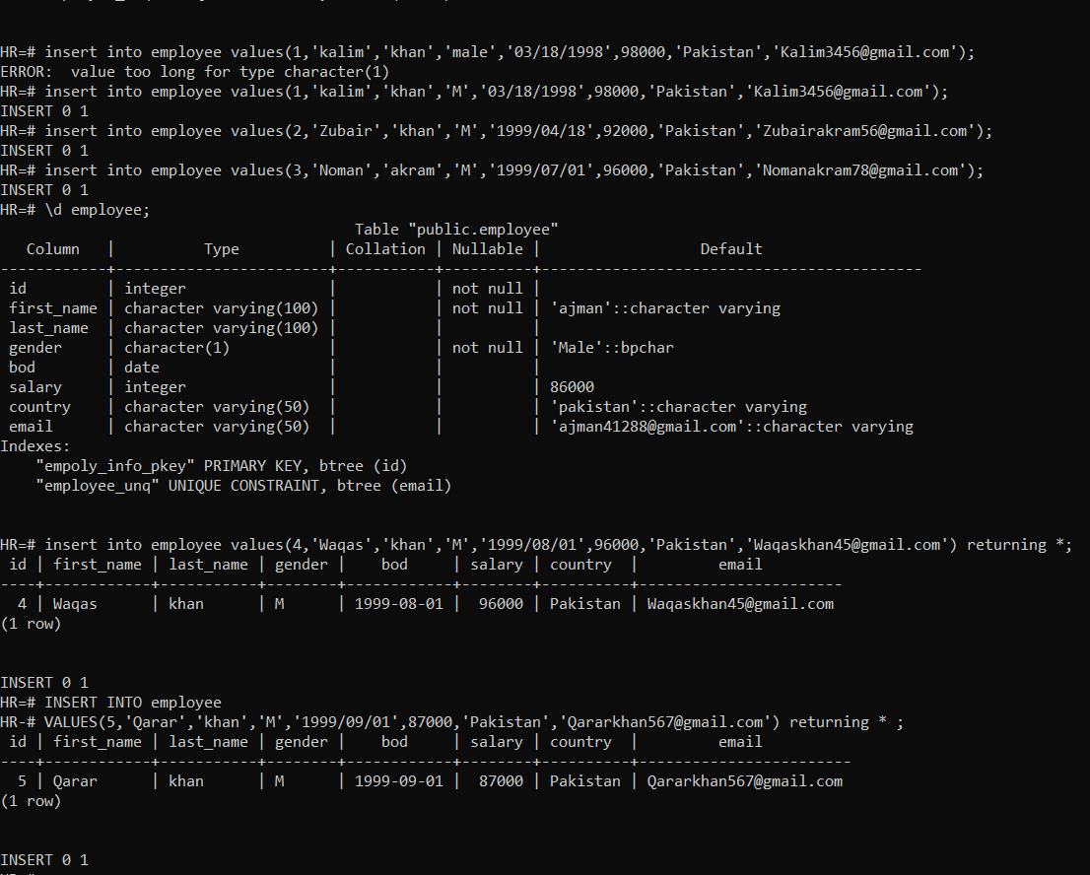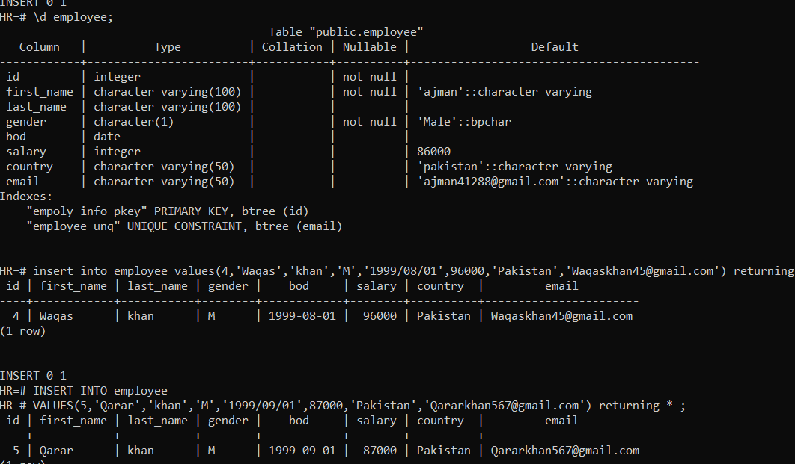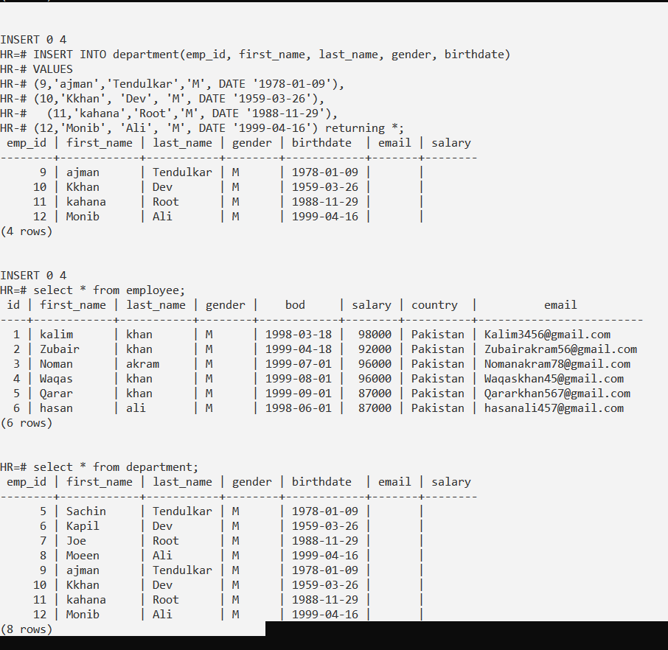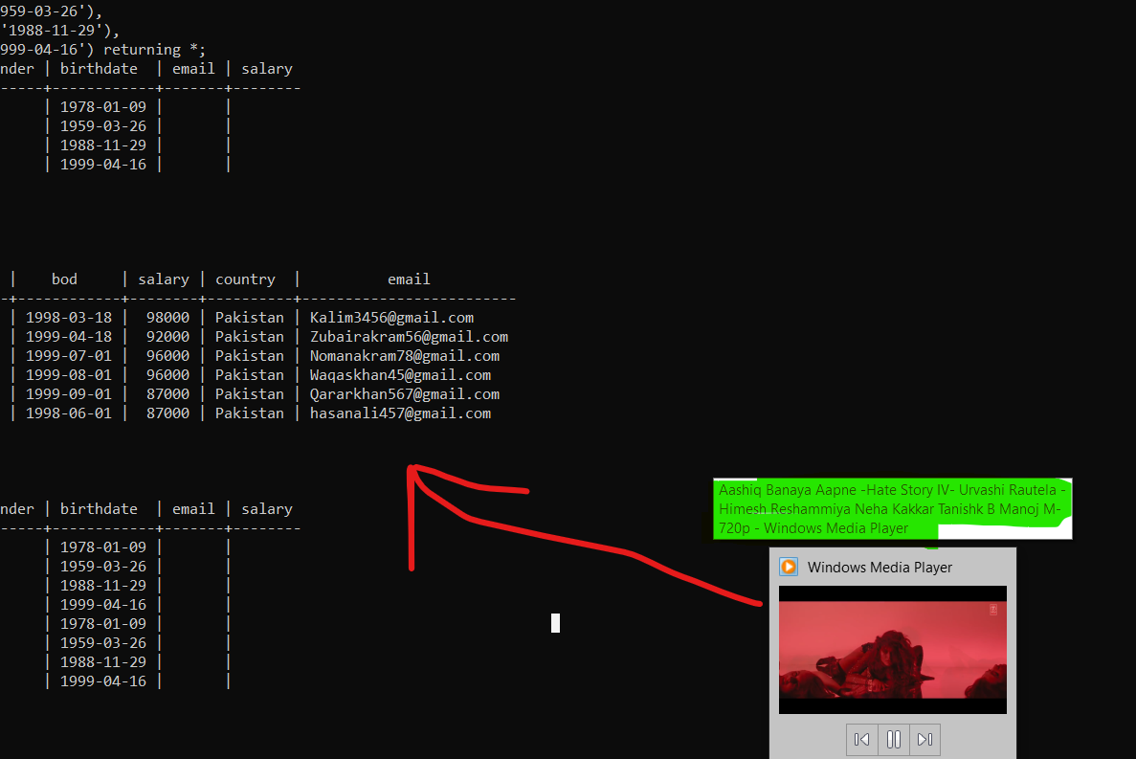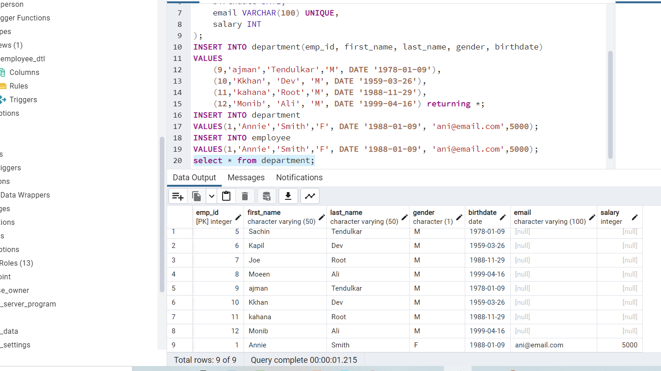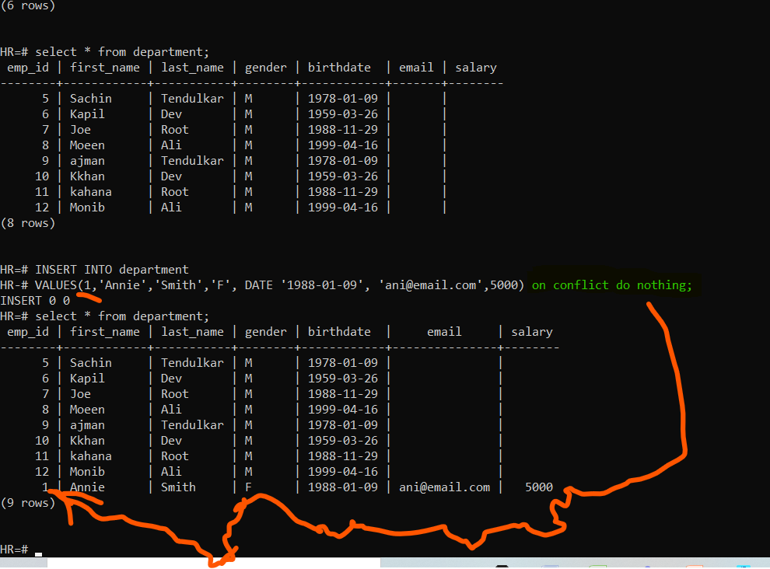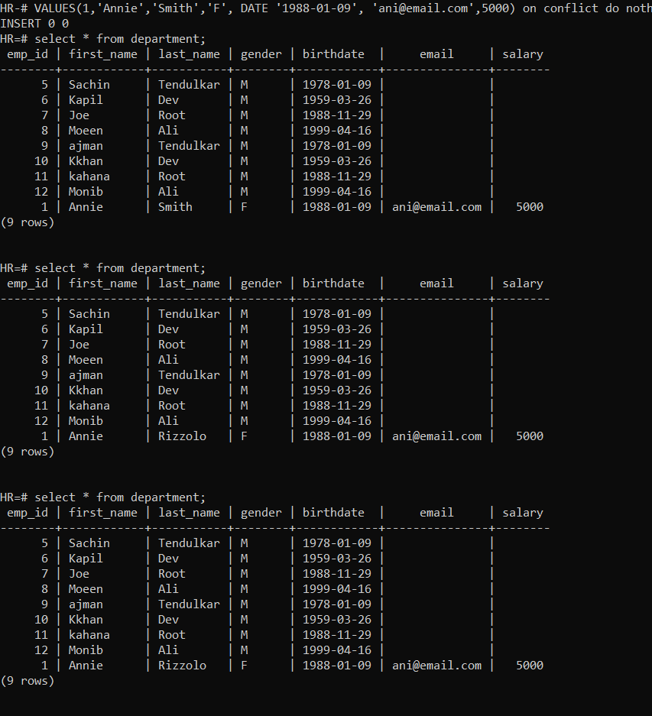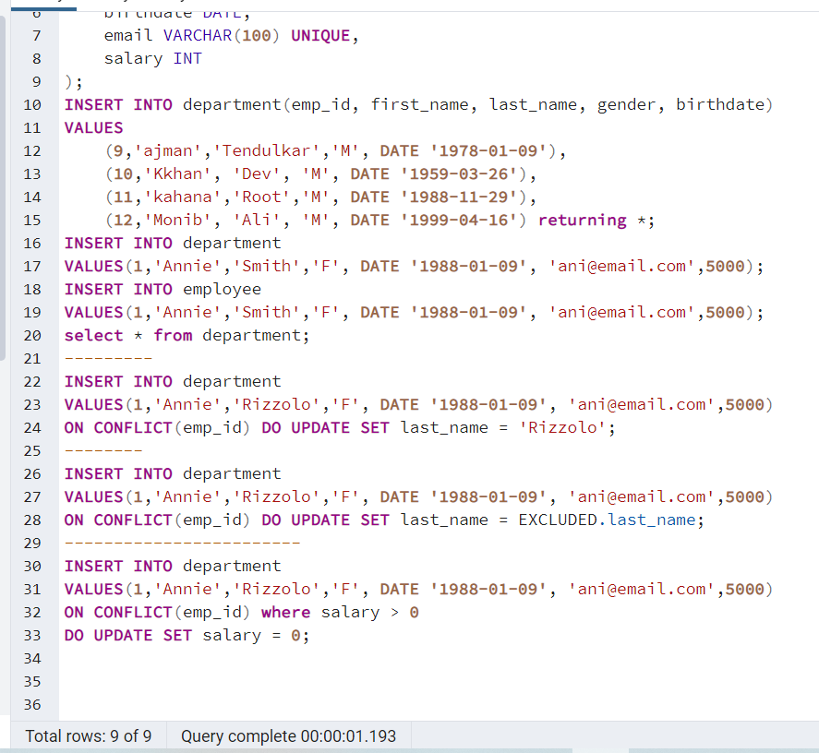

CREATE TABLE Department (

emp_id INT PRIMARY KEY,

first_name VARCHAR(50) NOT NULL,

last_name VARCHAR(50) NOT NULL,

gender CHAR(1),

birthdate DATE,

email VARCHAR(100) UNIQUE,

salary INT

);

INSERT INTO department(emp_id, first_name, last_name, gender, birthdate)

VALUES

(9,'ajman','Tendulkar','M', DATE '1978-01-09'),

(10,'Kkhan', 'Dev', 'M', DATE '1959-03-26'),

(11,'kahana','Root','M', DATE '1988-11-29'),

(12,'Monib', 'Ali', 'M', DATE '1999-04-16') returning *;

INSERT INTO department

VALUES(1,'Annie','Smith','F', DATE '1988-01-09', 'ani@email.com',5000);

INSERT INTO employee

VALUES(1,'Annie','Smith','F', DATE '1988-01-09', 'ani@email.com',5000);

select * from department;

---------

INSERT INTO department

VALUES(1,'Annie','Rizzolo','F', DATE '1988-01-09', 'ani@email.com',5000)

ON CONFLICT(emp_id) DO UPDATE SET last_name = 'Rizzolo';

--------

INSERT INTO department

VALUES(1,'Annie','Rizzolo','F', DATE '1988-01-09', 'ani@email.com',5000)

ON CONFLICT(emp_id) DO UPDATE SET last_name = EXCLUDED.last_name;

------------------------

INSERT INTO department

VALUES(1,'Annie','Rizzolo','F', DATE '1988-01-09', 'ani@email.com',5000)

ON CONFLICT(emp_id) where salary > 0

DO UPDATE SET salary = 0;

HR=# \d employeed;

Table "public.employeed"

Column | Type | Collation | Nullable | Default

------------+-----------------------+-----------+----------+---------

emp_id | integer | | not null |

first_name | character varying(50) | | not null |

last_name | character varying(50) | | not null |

gender | character(1) | | |

dept_id | integer | | not null |

Indexes:

"employeed_pkey" PRIMARY KEY, btree (emp_id)

Foreign-key constraints:

"employeed_dept_id_fkey" FOREIGN KEY (dept_id) REFERENCES department(dept_id)

HR=# drop table if exists employeed;

DROP TABLE

HR=# drop table if exists department;

DROP TABLE

HR=# CREATE TABLE employee(

HR(# emp_id INT PRIMARY KEY,

HR(# first_name VARCHAR(50) NOT NULL,

HR(# last_name VARCHAR(50) NOT NULL,

HR(# gender CHAR(1),

HR(# dept_id INT NOT NULL,

HR(#

HR(# FOREIGN KEY (dept_id) REFERENCES department(dept_id)

HR(# );

ERROR: relation "employee" already exists

HR=#

HR=# CREATE TABLE department (

HR(# dept_id INT PRIMARY KEY,

HR(# dept_name VARCHAR(100) NOT NULL

HR(# );

CREATE TABLE

HR=# TRUNCATE TABLE employea RESTART IDENTITY;

TRUNCATE TABLE

HR=# TRUNCATE TABLE employed CASCADE;

ERROR: relation "employed" does not exist

HR=# TRUNCATE TABLE employe CASCADE;

TRUNCATE TABLE

HR=# alter table employee add column address varchar(50);

ALTER TABLE

HR=# \d employee

Table "public.employee"

Column | Type | Collation | Nullable | Default

------------------+------------------------+-----------+----------+---------

id | integer | | |

first_name | character varying(50) | | |

last_name | character varying(50) | | |

gender | character(1) | | |

birthdate | date | | |

email_id | character varying(100) | | |

country_of_birth | character varying(50) | | |

address | character varying(50) | | |

HR=# alter table employee drop column address cascade;

ALTER TABLE

HR=# \d employee;

Table "public.employee"

Column | Type | Collation | Nullable | Default

------------------+------------------------+-----------+----------+---------

id | integer | | |

first_name | character varying(50) | | |

last_name | character varying(50) | | |

gender | character(1) | | |

birthdate | date | | |

email_id | character varying(100) | | |

country_of_birth | character varying(50) | | |

HR=# alter table employee

HR-# alter column first_name type varchar(100),

HR-# alter column last_name type varchar(100);

ALTER TABLE

HR=# \d employee;

Table "public.employee"

Column | Type | Collation | Nullable | Default

------------------+------------------------+-----------+----------+---------

id | integer | | |

first_name | character varying(100) | | |

last_name | character varying(100) | | |

gender | character(1) | | |

birthdate | date | | |

email_id | character varying(100) | | |

country_of_birth | character varying(50) | | |

HR=# alter table employee rename column birthdate to BOD;

ALTER TABLE

HR=# \d employee;

Table "public.employee"

Column | Type | Collation | Nullable | Default

------------------+------------------------+-----------+----------+---------

id | integer | | |

first_name | character varying(100) | | |

last_name | character varying(100) | | |

gender | character(1) | | |

bod | date | | |

email_id | character varying(100) | | |

country_of_birth | character varying(50) | | |

HR=# alter table employee rename to empoly_info;

ALTER TABLE

HR=# \d employ_info;

Did not find any relation named "employ_info".

HR=# \d empoly_info;

Table "public.empoly_info"

Column | Type | Collation | Nullable | Default

------------------+------------------------+-----------+----------+---------

id | integer | | |

first_name | character varying(100) | | |

last_name | character varying(100) | | |

gender | character(1) | | |

bod | date | | |

email_id | character varying(100) | | |

country_of_birth | character varying(50) | | |

HR=# alter table empoly_info alter column gender set not null;

ALTER TABLE

HR=# \d empoly_info;

Table "public.empoly_info"

Column | Type | Collation | Nullable | Default

------------------+------------------------+-----------+----------+---------

id | integer | | |

first_name | character varying(100) | | |

last_name | character varying(100) | | |

gender | character(1) | | not null |

bod | date | | |

email_id | character varying(100) | | |

country_of_birth | character varying(50) | | |

HR=# alter table empoly_info add column salary int not null;

ALTER TABLE

HR=# \d empoly_info;

Table "public.empoly_info"

Column | Type | Collation | Nullable | Default

------------------+------------------------+-----------+----------+---------

id | integer | | |

first_name | character varying(100) | | |

last_name | character varying(100) | | |

gender | character(1) | | not null |

bod | date | | |

email_id | character varying(100) | | |

country_of_birth | character varying(50) | | |

salary | integer | | not null |

HR=# alter table empoly_info alter column salary drop not null;

ALTER TABLE

HR=# \d empoly_info;

Table "public.empoly_info"

Column | Type | Collation | Nullable | Default

------------------+------------------------+-----------+----------+---------

id | integer | | |

first_name | character varying(100) | | |

last_name | character varying(100) | | |

gender | character(1) | | not null |

bod | date | | |

email_id | character varying(100) | | |

country_of_birth | character varying(50) | | |

salary | integer | | |

HR=# ALTER TABLE empoly_info ADD CONSTRAINT first_name CHECK (char_length(first_name) > 1);

ALTER TABLE

HR=# \d empoly_info;

Table "public.empoly_info"

Column | Type | Collation | Nullable | Default

------------------+------------------------+-----------+----------+---------

id | integer | | |

first_name | character varying(100) | | |

last_name | character varying(100) | | |

gender | character(1) | | not null |

bod | date | | |

email_id | character varying(100) | | |

country_of_birth | character varying(50) | | |

salary | integer | | |

Check constraints:

"first_name" CHECK (char_length(first_name::text) > 1)

HR=# alter table empoly_info drop constraint first_name;

ALTER TABLE

HR=# \d empoly_info;

Table "public.empoly_info"

Column | Type | Collation | Nullable | Default

------------------+------------------------+-----------+----------+---------

id | integer | | |

first_name | character varying(100) | | |

last_name | character varying(100) | | |

gender | character(1) | | not null |

bod | date | | |

email_id | character varying(100) | | |

country_of_birth | character varying(50) | | |

salary | integer | | |

HR=# alter table empoly_info add primary key (id);

ALTER TABLE

HR=# \d empoly_info;

Table "public.empoly_info"

Column | Type | Collation | Nullable | Default

------------------+------------------------+-----------+----------+---------

id | integer | | not null |

first_name | character varying(100) | | |

last_name | character varying(100) | | |

gender | character(1) | | not null |

bod | date | | |

email_id | character varying(100) | | |

country_of_birth | character varying(50) | | |

salary | integer | | |

Indexes:

"empoly_info_pkey" PRIMARY KEY, btree (id)

HR=# ALTER TABLE myschema.employee SET SCHEMA yourschema;

ERROR: schema "myschema" does not exist

HR=# alter table empoly_info rename to employee;

ALTER TABLE

HR=# \d employee;

Table "public.employee"

Column | Type | Collation | Nullable | Default

------------------+------------------------+-----------+----------+---------

id | integer | | not null |

first_name | character varying(100) | | |

last_name | character varying(100) | | |

gender | character(1) | | not null |

bod | date | | |

email_id | character varying(100) | | |

country_of_birth | character varying(50) | | |

salary | integer | | |

Indexes:

"empoly_info_pkey" PRIMARY KEY, btree (id)

HR=# alter table employee alter column salary set default 0;

ALTER TABLE

HR=# \d employee;

Table "public.employee"

Column | Type | Collation | Nullable | Default

------------------+------------------------+-----------+----------+---------

id | integer | | not null |

first_name | character varying(100) | | |

last_name | character varying(100) | | |

gender | character(1) | | not null |

bod | date | | |

email_id | character varying(100) | | |

country_of_birth | character varying(50) | | |

salary | integer | | | 0

Indexes:

"empoly_info_pkey" PRIMARY KEY, btree (id)

HR=# alter table employee alter column date set default '10/05/2022';

ERROR: column "date" of relation "employee" does not exist

HR=# alter table employee alter column bod set default '10/05/2022';

ALTER TABLE

HR=# \d employee;

Table "public.employee"

Column | Type | Collation | Nullable | Default

------------------+------------------------+-----------+----------+--------------------

id | integer | | not null |

first_name | character varying(100) | | |

last_name | character varying(100) | | |

gender | character(1) | | not null |

bod | date | | | '2022-10-05'::date

email_id | character varying(100) | | |

country_of_birth | character varying(50) | | |

salary | integer | | | 0

Indexes:

"empoly_info_pkey" PRIMARY KEY, btree (id)

HR=# alter table employee alter column salary set default 850000;

ALTER TABLE

HR=# \d empoloyee;

Did not find any relation named "empoloyee".

HR=# \d employee;

Table "public.employee"

Column | Type | Collation | Nullable | Default

------------------+------------------------+-----------+----------+--------------------

id | integer | | not null |

first_name | character varying(100) | | |

last_name | character varying(100) | | |

gender | character(1) | | not null |

bod | date | | | '2022-10-05'::date

email_id | character varying(100) | | |

country_of_birth | character varying(50) | | |

salary | integer | | | 850000

Indexes:

"empoly_info_pkey" PRIMARY KEY, btree (id)

HR=# alter table employee alter column gender set default 'Male';

ALTER TABLE

HR=# \d employee;

Table "public.employee"

Column | Type | Collation | Nullable | Default

------------------+------------------------+-----------+----------+--------------------

id | integer | | not null |

first_name | character varying(100) | | |

last_name | character varying(100) | | |

gender | character(1) | | not null | 'Male'::bpchar

bod | date | | | '2022-10-05'::date

email_id | character varying(100) | | |

country_of_birth | character varying(50) | | |

salary | integer | | | 850000

Indexes:

"empoly_info_pkey" PRIMARY KEY, btree (id)

HR=# alter table employee alter column dob drop default;

ERROR: column "dob" of relation "employee" does not exist

HR=# alter table employee alter column bod drop default;

ALTER TABLE

HR=# \d employee;

Table "public.employee"

Column | Type | Collation | Nullable | Default

------------------+------------------------+-----------+----------+----------------

id | integer | | not null |

first_name | character varying(100) | | |

last_name | character varying(100) | | |

gender | character(1) | | not null | 'Male'::bpchar

bod | date | | |

email_id | character varying(100) | | |

country_of_birth | character varying(50) | | |

salary | integer | | | 850000

Indexes:

"empoly_info_pkey" PRIMARY KEY, btree (id)

HR=# \d employee;

Table "public.employee"

Column | Type | Collation | Nullable | Default

------------------+------------------------+-----------+----------+----------------------------

id | integer | | not null |

first_name | character varying(100) | | not null | 'ajman'::character varying

last_name | character varying(100) | | |

gender | character(1) | | not null | 'Male'::bpchar

bod | date | | |

email_id | character varying(100) | | |

country_of_birth | character varying(50) | | |

salary | integer | | | 850000

Indexes:

"empoly_info_pkey" PRIMARY KEY, btree (id)

HR=# alter table employee drop column email_id;

ERROR: cannot drop column email_id of table employee because other objects depend on it

DETAIL: view employee_dtl depends on column email_id of table employee

HINT: Use DROP ... CASCADE to drop the dependent objects too.

HR=# alter table employee drop column email_id cascade;

NOTICE: drop cascades to view employee_dtl

ALTER TABLE

HR=# \d employee;

Table "public.employee"

Column | Type | Collation | Nullable | Default

------------------+------------------------+-----------+----------+----------------------------

id | integer | | not null |

first_name | character varying(100) | | not null | 'ajman'::character varying

last_name | character varying(100) | | |

gender | character(1) | | not null | 'Male'::bpchar

bod | date | | |

country_of_birth | character varying(50) | | |

salary | integer | | | 850000

Indexes:

"empoly_info_pkey" PRIMARY KEY, btree (id)

HR=# ALTER TABLE employee

HR-# DROP COLUMN email CASCADE,

HR-# DROP COLUMN gender;

ERROR: column "email" of relation "employee" does not exist

HR=# alter table employee

HR-# drop column country_of_birth,

HR-# drop column salary;

ALTER TABLE

HR=# \d employee;

Table "public.employee"

Column | Type | Collation | Nullable | Default

------------+------------------------+-----------+----------+----------------------------

id | integer | | not null |

first_name | character varying(100) | | not null | 'ajman'::character varying

last_name | character varying(100) | | |

gender | character(1) | | not null | 'Male'::bpchar

bod | date | | |

Indexes:

"empoly_info_pkey" PRIMARY KEY, btree (id)

HR=# \d employee;

Table "public.employee"

Column | Type | Collation | Nullable | Default

------------+------------------------+-----------+----------+-------------------------------------------

id | integer | | not null |

first_name | character varying(100) | | not null | 'ajman'::character varying

last_name | character varying(100) | | |

gender | character(1) | | not null | 'Male'::bpchar

bod | date | | |

salary | integer | | | 86000

country | character varying(50) | | | 'pakistan'::character varying

email | character varying(50) | | | 'ajman41288@gmail.com'::character varying

Indexes:

"empoly_info_pkey" PRIMARY KEY, btree (id)

"employee_unq" UNIQUE CONSTRAINT, btree (email)

HR=# insert into employee values(1,'kalim','khan','male','03/18/1998',98000,'Pakistan','Kalim3456@gmail.com');

ERROR: value too long for type character(1)

HR=# insert into employee values(1,'kalim','khan','M','03/18/1998',98000,'Pakistan','Kalim3456@gmail.com');

INSERT 0 1

HR=# insert into employee values(2,'Zubair','khan','M','1999/04/18',92000,'Pakistan','Zubairakram56@gmail.com');

INSERT 0 1

HR=# insert into employee values(3,'Noman','akram','M','1999/07/01',96000,'Pakistan','Nomanakram78@gmail.com');

INSERT 0 1

HR=# \d employee;

Table "public.employee"

Column | Type | Collation | Nullable | Default

------------+------------------------+-----------+----------+-------------------------------------------

id | integer | | not null |

first_name | character varying(100) | | not null | 'ajman'::character varying

last_name | character varying(100) | | |

gender | character(1) | | not null | 'Male'::bpchar

bod | date | | |

salary | integer | | | 86000

country | character varying(50) | | | 'pakistan'::character varying

email | character varying(50) | | | 'ajman41288@gmail.com'::character varying

Indexes:

"empoly_info_pkey" PRIMARY KEY, btree (id)

"employee_unq" UNIQUE CONSTRAINT, btree (email)

HR=# insert into employee values(4,'Waqas','khan','M','1999/08/01',96000,'Pakistan','Waqaskhan45@gmail.com') returning *;

id | first_name | last_name | gender | bod | salary | country | email

----+------------+-----------+--------+------------+--------+----------+-----------------------

4 | Waqas | khan | M | 1999-08-01 | 96000 | Pakistan | Waqaskhan45@gmail.com

(1 row)

INSERT 0 1

HR=# INSERT INTO employee

HR-# VALUES(5,'Qarar','khan','M','1999/09/01',87000,'Pakistan','Qararkhan567@gmail.com') returning * ;

id | first_name | last_name | gender | bod | salary | country | email

----+------------+-----------+--------+------------+--------+----------+------------------------

5 | Qarar | khan | M | 1999-09-01 | 87000 | Pakistan | Qararkhan567@gmail.com

(1 row)

INSERT 0 1

HR=# VALUES(6,'hasan','ali','M','1998/06/01',87000,'Pakistan','hasanali457@gmail.com') returning id;

ERROR: syntax error at or near "returning"

LINE 1: .../06/01',87000,'Pakistan','hasanali457@gmail.com') returning ...

^

HR=# VALUES(6,'hasan','ali','M','1998/06/01',87000,'Pakistan','hasanali457@gmail.com') returning emp_id;

ERROR: syntax error at or near "returning"

LINE 1: .../06/01',87000,'Pakistan','hasanali457@gmail.com') returning ...

^

HR=# insert into employee VALUES(6,'hasan','ali','M','1998/06/01',87000,'Pakistan','hasanali457@gmail.com') returning id;

id

----

6

(1 row)

INSERT 0 1

HR=# INSERT INTO department(emp_id, first_name, last_name, gender, birthdate)

HR-# VALUES

HR-# (5,'Sachin','Tendulkar','M', DATE '1978-01-09'),

HR-# (6,'Kapil', 'Dev', 'M', DATE '1959-03-26'),

HR-# (7,'Joe','Root','M', DATE '1988-11-29'),

HR-# (8,'Moeen', 'Ali', 'M', DATE '1999-04-16') returning *;

emp_id | first_name | last_name | gender | birthdate | email | salary

--------+------------+-----------+--------+------------+-------+--------

5 | Sachin | Tendulkar | M | 1978-01-09 | |

6 | Kapil | Dev | M | 1959-03-26 | |

7 | Joe | Root | M | 1988-11-29 | |

8 | Moeen | Ali | M | 1999-04-16 | |

(4 rows)

INSERT 0 4

HR=# INSERT INTO department(emp_id, first_name, last_name, gender, birthdate)

HR-# VALUES

HR-# (9,'ajman','Tendulkar','M', DATE '1978-01-09'),

HR-# (10,'Kkhan', 'Dev', 'M', DATE '1959-03-26'),

HR-# (11,'kahana','Root','M', DATE '1988-11-29'),

HR-# (12,'Monib', 'Ali', 'M', DATE '1999-04-16') returning *;

emp_id | first_name | last_name | gender | birthdate | email | salary

--------+------------+-----------+--------+------------+-------+--------

9 | ajman | Tendulkar | M | 1978-01-09 | |

10 | Kkhan | Dev | M | 1959-03-26 | |

11 | kahana | Root | M | 1988-11-29 | |

12 | Monib | Ali | M | 1999-04-16 | |

(4 rows)

INSERT 0 4

HR=# select * from employee;

id | first_name | last_name | gender | bod | salary | country | email

----+------------+-----------+--------+------------+--------+----------+-------------------------

1 | kalim | khan | M | 1998-03-18 | 98000 | Pakistan | Kalim3456@gmail.com

2 | Zubair | khan | M | 1999-04-18 | 92000 | Pakistan | Zubairakram56@gmail.com

3 | Noman | akram | M | 1999-07-01 | 96000 | Pakistan | Nomanakram78@gmail.com

4 | Waqas | khan | M | 1999-08-01 | 96000 | Pakistan | Waqaskhan45@gmail.com

5 | Qarar | khan | M | 1999-09-01 | 87000 | Pakistan | Qararkhan567@gmail.com

6 | hasan | ali | M | 1998-06-01 | 87000 | Pakistan | hasanali457@gmail.com

(6 rows)

HR=# select * from department;

emp_id | first_name | last_name | gender | birthdate | email | salary

--------+------------+-----------+--------+------------+-------+--------

5 | Sachin | Tendulkar | M | 1978-01-09 | |

6 | Kapil | Dev | M | 1959-03-26 | |

7 | Joe | Root | M | 1988-11-29 | |

8 | Moeen | Ali | M | 1999-04-16 | |

9 | ajman | Tendulkar | M | 1978-01-09 | |

10 | Kkhan | Dev | M | 1959-03-26 | |

11 | kahana | Root | M | 1988-11-29 | |

12 | Monib | Ali | M | 1999-04-16 | |

(8 rows)

HR=# INSERT INTO department

HR-# VALUES(1,'Annie','Smith','F', DATE '1988-01-09', 'ani@email.com',5000) on conflict do nothing;

INSERT 0 0

HR=# select * from department;

emp_id | first_name | last_name | gender | birthdate | email | salary

--------+------------+-----------+--------+------------+---------------+--------

5 | Sachin | Tendulkar | M | 1978-01-09 | |

6 | Kapil | Dev | M | 1959-03-26 | |

7 | Joe | Root | M | 1988-11-29 | |

8 | Moeen | Ali | M | 1999-04-16 | |

9 | ajman | Tendulkar | M | 1978-01-09 | |

10 | Kkhan | Dev | M | 1959-03-26 | |

11 | kahana | Root | M | 1988-11-29 | |

12 | Monib | Ali | M | 1999-04-16 | |

1 | Annie | Smith | F | 1988-01-09 | ani@email.com | 5000

(9 rows)

HR=# select * from department;

emp_id | first_name | last_name | gender | birthdate | email | salary

--------+------------+-----------+--------+------------+---------------+--------

5 | Sachin | Tendulkar | M | 1978-01-09 | |

6 | Kapil | Dev | M | 1959-03-26 | |

7 | Joe | Root | M | 1988-11-29 | |

8 | Moeen | Ali | M | 1999-04-16 | |

9 | ajman | Tendulkar | M | 1978-01-09 | |

10 | Kkhan | Dev | M | 1959-03-26 | |

11 | kahana | Root | M | 1988-11-29 | |

12 | Monib | Ali | M | 1999-04-16 | |

1 | Annie | Rizzolo | F | 1988-01-09 | ani@email.com | 5000

(9 rows)

HR=# select * from department;

emp_id | first_name | last_name | gender | birthdate | email | salary

--------+------------+-----------+--------+------------+---------------+--------

5 | Sachin | Tendulkar | M | 1978-01-09 | |

6 | Kapil | Dev | M | 1959-03-26 | |

7 | Joe | Root | M | 1988-11-29 | |

8 | Moeen | Ali | M | 1999-04-16 | |

9 | ajman | Tendulkar | M | 1978-01-09 | |

10 | Kkhan | Dev | M | 1959-03-26 | |

11 | kahana | Root | M | 1988-11-29 | |

12 | Monib | Ali | M | 1999-04-16 | |

1 | Annie | Rizzolo | F | 1988-01-09 | ani@email.com | 5000

(9 rows)

HR=# select * from department;

emp_id | first_name | last_name | gender | birthdate | email | salary

--------+------------+-----------+--------+------------+---------------+--------

5 | Sachin | Tendulkar | M | 1978-01-09 | |

6 | Kapil | Dev | M | 1959-03-26 | |

7 | Joe | Root | M | 1988-11-29 | |

8 | Moeen | Ali | M | 1999-04-16 | |

9 | ajman | Tendulkar | M | 1978-01-09 | |

10 | Kkhan | Dev | M | 1959-03-26 | |

11 | kahana | Root | M | 1988-11-29 | |

12 | Monib | Ali | M | 1999-04-16 | |

1 | Annie | Rizzolo | F | 1988-01-09 | ani@email.com | 0

(9 rows)

HR=# select * from department;

emp_id | first_name | last_name | gender | birthdate | email | salary

--------+------------+-----------+--------+------------+---------------+--------

5 | Sachin | Tendulkar | M | 1978-01-09 | |

6 | Kapil | Dev | M | 1959-03-26 | |

7 | Joe | Root | M | 1988-11-29 | |

8 | Moeen | Ali | M | 1999-04-16 | |

9 | ajman | Tendulkar | M | 1978-01-09 | |

10 | Kkhan | Dev | M | 1959-03-26 | |

11 | kahana | Root | M | 1988-11-29 | |

12 | Monib | Ali | M | 1999-04-16 | |

1 | Annie | Rizzolo | F | 1988-01-09 | ani@email.com | 0

(9 rows)

HR=#